**ENVIRONMENT SETUP**

Installing Microsoft visual studio code, I downloaded the executable file. Then ran the file and followed the setup wizard, as follows:  
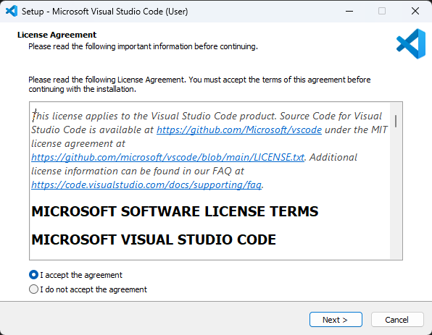

Accept terms of agreement

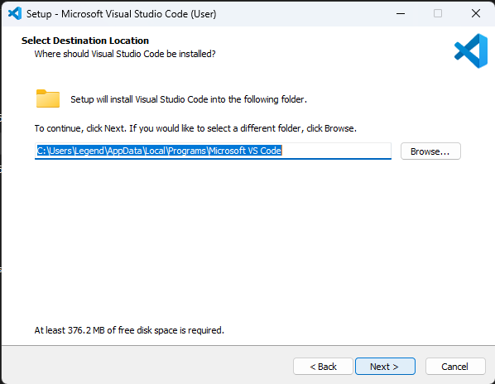

Choose destination folder

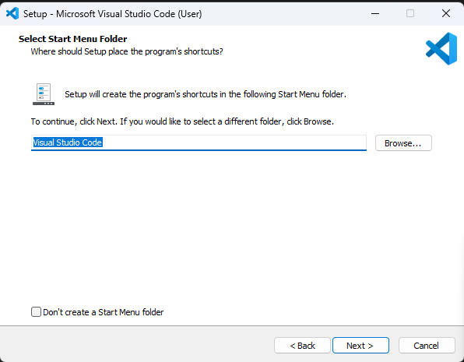

Choose start menu name for visual studio

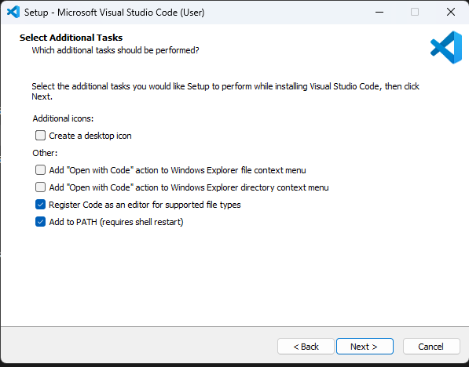

And other optional choices before installation

Installing the version control system also downloaded the executable and followed the installation wizard. And the steps are as follows:

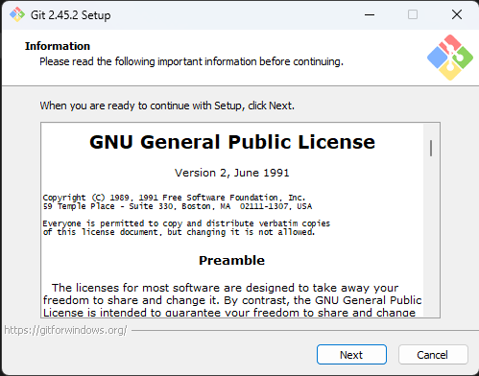

Accept the terms

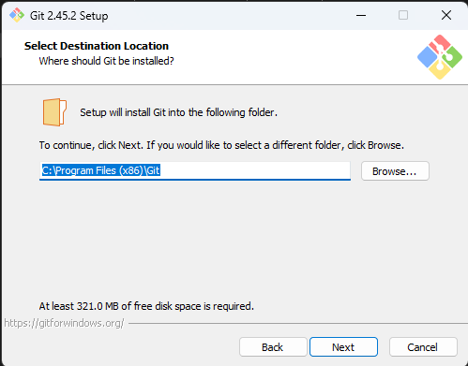

Choose a suitable location for storing the program files.

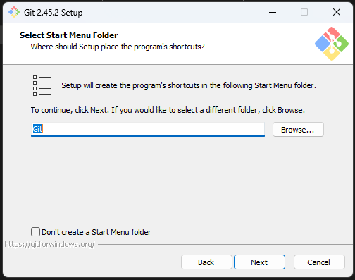

Choose a start menu name for the program.

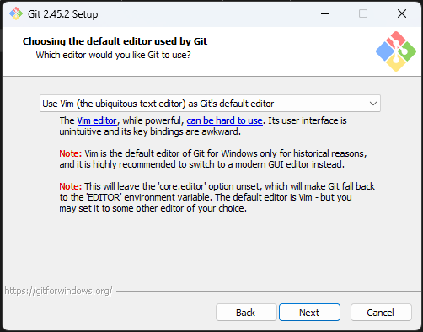

Other optional services that come with the git program.

Followed all through to the installation end.

For installation of the dart sdk, I download the compressed file first, extracted it then copied the folder to the root directory and added the path to system variables.

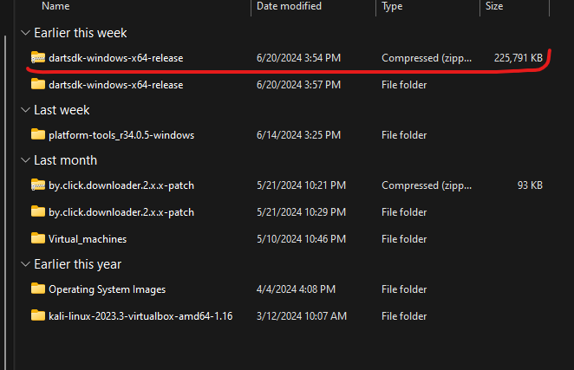

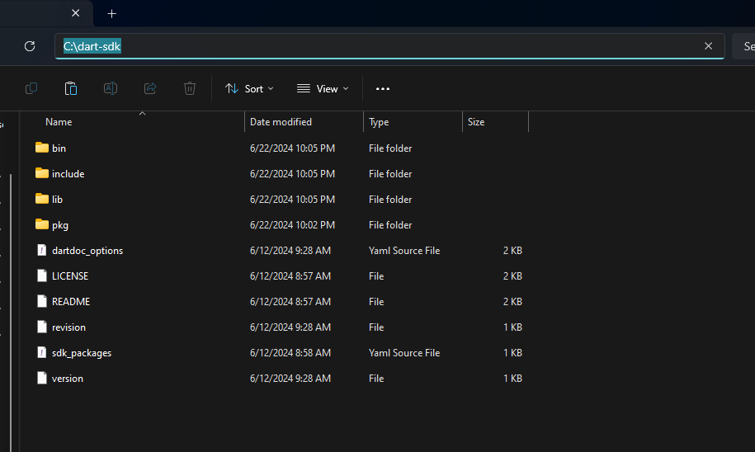

Root folder

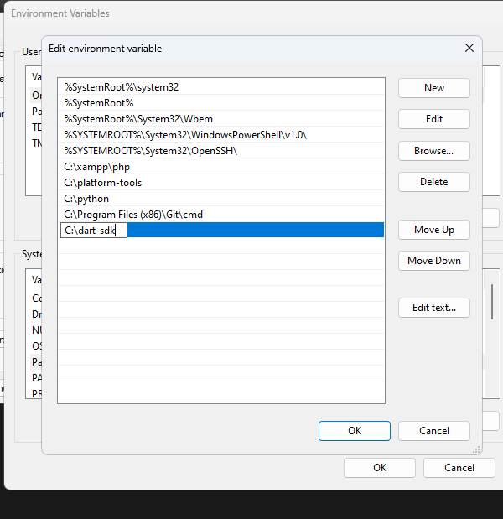

System path

Proceeded with installation of mysql database, used the mysql installer to install the server and client.

Steps are as follows:

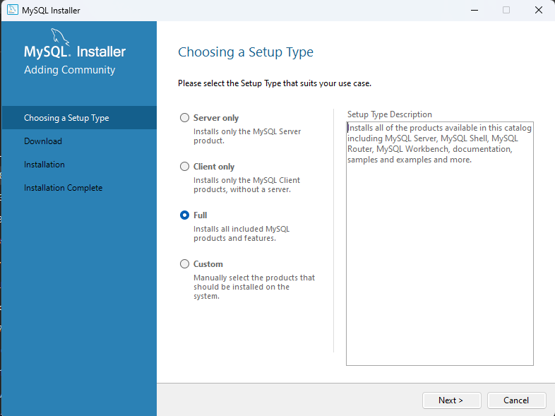

Started with choosing the products to install.

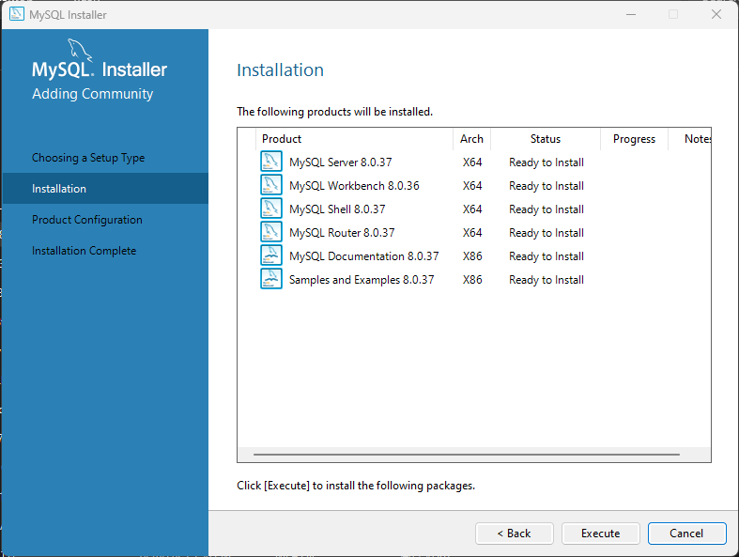

Then installed them all

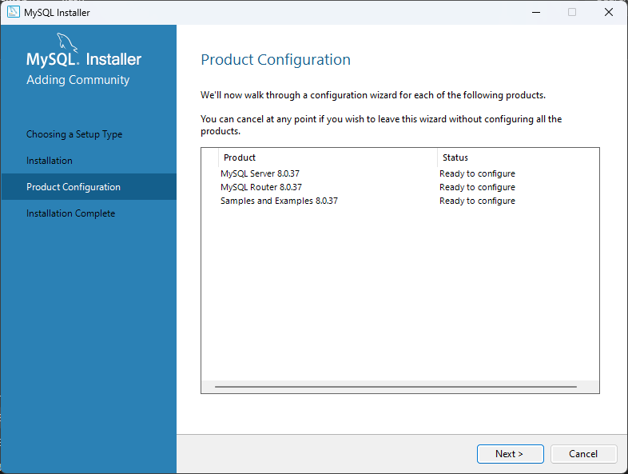

After installation I did configuration of the products.

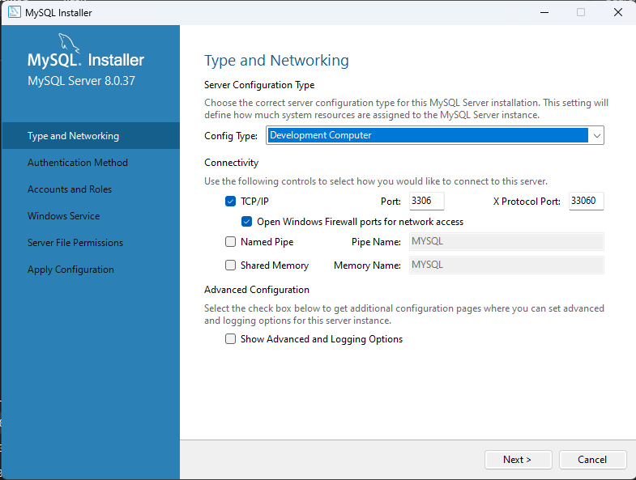

Followed through all configuration of the mysql server

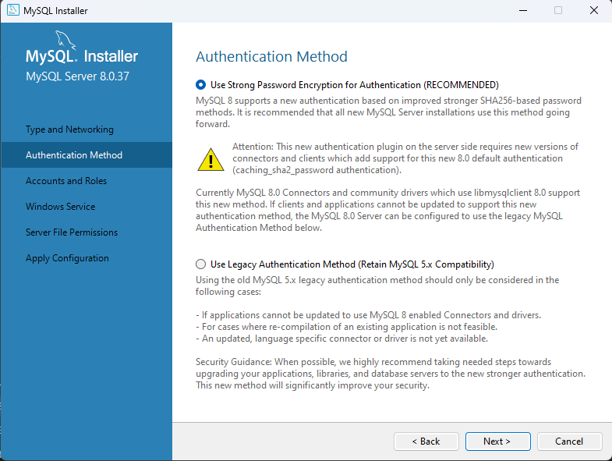

Choosing the authentication method for the server.

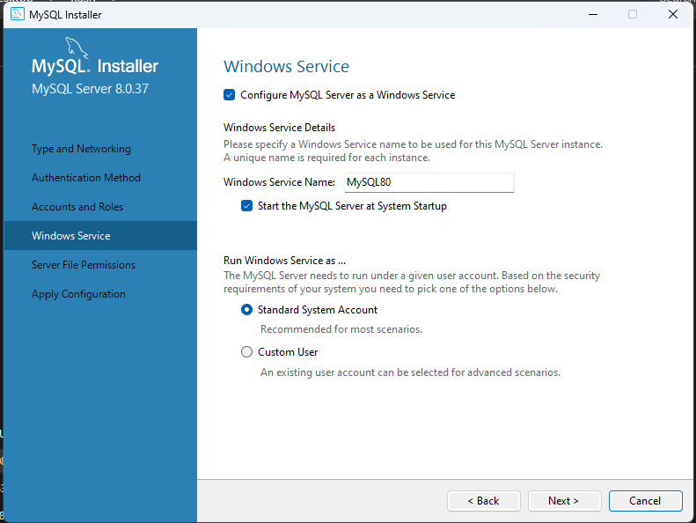

After that I configured the service name of the program.

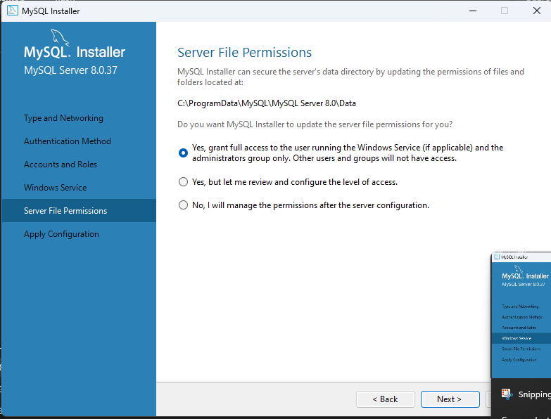

Then configured the server file permissions.

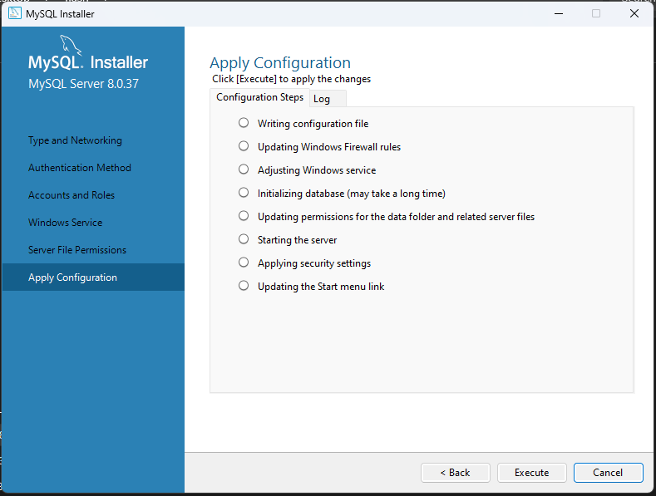

Then finished the full configuration.